To:
Date:
Quote No ________
Greetings,
About us – (write some details about your company)
Example
The company was developed to provide services for a wide range of the population: Senior staff, workers, youth movements and the security forces. ..... more.
Link to our website
https://www.lasertag-il.com/
Link to our facebook page
https://www.facebook.com/FalconLazerTag

How does it looks click here
The arena
Wherever you want, we will set up a challenging water tag arena assembly with our colorful water tag barrels and our special accessories, each arena will be divided into two sides on each side four barrels containing 250 liters/55 galons per barrel + a neutral barrel in the center. Waterproof sensors that count points live on a huge scoreboard.The sensors are placed on the barrels / shelters
At the end of each round our team refills the barrels.
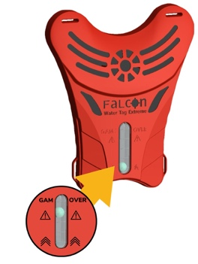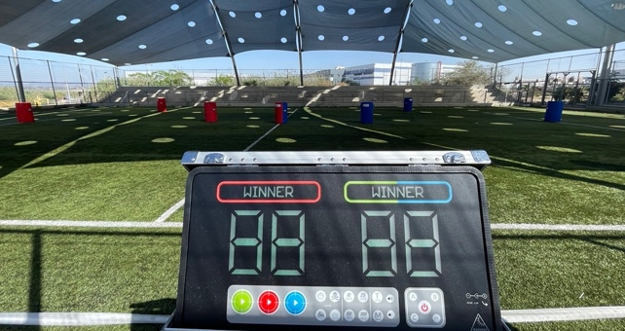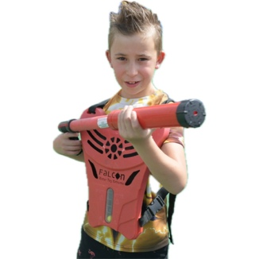
The game
The game is suitable for groups of 50 to 200 people at a time (depending on the size of the arena) In one hour of play, three different games are played.
- Stay alive - The purpose of the first game is to fill the opponent's vests. Once water is splashed into the holes on the vest the measurement ball starts going up, once the ball reaches the top the opponent team receives 20 points. Players are not taken out , instructors empty the vest and the players continues. + the sensors around the arena are spread out ten waterproof sensors that light up in blue and red.
- Capture the flag - The purpose of the second game is the basis of the first game but this time we add our cone flags
- Battle Royale - The goal of the third game is I experienced the game is everyone against everyone no friends no teams whoever his vest fills comes out.
At the end of each game our referee team announces the winners.

These terms and condition work great for us, but they are just a recommendation for each and every one of you read them carefully and check that they are OK with your local rules
Comments:
I confirm the event booking according to the details below:
Event date:
hour:
Place :
Amount of people :
Price:
Minimum payment guaranteed:
Terms of Payment :
Contact person at the field:
Important customer comments
- Mandatory closed shoes (not flip flops or crocs)
- In the Water Tag mobile activity, it is mandatory to coordinate an approved high-pressure water connection short distance from the event area
- We know that the minimum age to participate in the water tag is 6 and up. Under this age it will not be possible to play
- Final amount of people must be confirmed up to one week before the event
- Prices include VAT
- The activity is conditional on the weather conditions
- Playing time includes dressing and briefing
- Must arrive about 15 minutes before the scheduled time start (any delay will result in a shortening or cancellation of the game - full payment)
- Cancellation fees in the days of Corona: In case of cancellation in the circumstances of Corona which are anchored in accordance with the guidelines of government bodies will not charge a fee
It is important to note that Falcon reserves the right to cancel an event on its part in the event of a high closure / illness in accordance with state guidelines.
- Standard cancellation fee: If the customer wishes to cancel his order for any reason, he will pay Falcon Laser Tag a cancellation fee according to the details below:
In case of cancellation and no moving date for any reason no down payment will be refunded
Cancellation of an activity with a notice of up to 10 business days from the date of the activity will be charged 10% of the total cost of the activity.
- Cancellation of an activity with a notice of up to 5 business days from the date of the activity will be charged 50% of the total cost of the activity.
Cancellation of activity with notice of up to 3 business days from the date of activity will be charged in full.
In the event of stormy weather that does not allow the activity to take place, it will be possible to set a new date within a period of up to one month from the day of the activity.
- We approve our additions to the professional mailing lists for sending news and updates (for example, lectures, workshops, new products and more
* The event is not closed and approved before signing this document and payment *
If you have fix Arena and not mobile
* In these Falcon complexes, it is explicitly stated that there is no obligation for a private arena - additional people can be included in the game with you *

